Installing SQL Server

Getting Started
Installing SQL Server is not too difficult, but there are a few tips that can make the process go more smoothly. In this document we have outlined those tips. If you would like a video version of these please navigate to our website at: http://www.NorthwestTech.org/InstallingSoftware. Here you can also check for the latest version of these instructions and any additional content. You may also want to check out Microsoft's official guide to installing SQL Server at: http://technet.microsoft.com/en-us/sqlserver/install.aspx
Note: These instructions are for SQL 2012, but they are also applicable to SQL 2005, 2008, and 2008 R2.
- 1) Launch the SQL Server setup program by locating the Setup.exe file from the downloaded SQL Server files or on the SQL DVD. Double-click Setup.exe and the Installation Wizard starts up the SQL Server Installation Center.
Important: To install SQL Server you need administrator-level privileges. The easiest way to achieve this is to right-click the menu item, select Run as Administrator, and then answer" Yes" to access administrator-level privileges while running this program. In Windows 7 and Vista, just logging in with an administrator account is not enough. For more information, search the Web for “Windows 7 True Administrator and User Access Control.”
- 2) Select the Installation page from the SQL Server Installation Center dialog window (Figure 1). To create a new installation of SQL Server, click "New SQL Server stand-alone installation or add features to an existing installation" option.
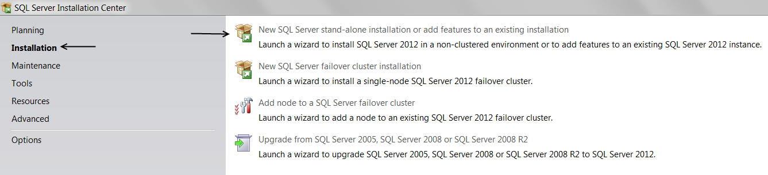
Figure 1. Choosing to install a new stand-alone installation.
- Wait while the System support checker runs a discovery operation on your computer. This should take only a few seconds, but can take a few minutes on a slow machine. A dialog is displayed while it is working.

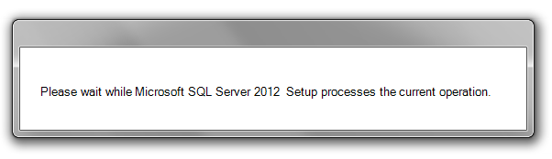
Figure 2. The installation starts by checking your systems configuration.
- Once the Setup support shows that the completed operations have passed, click OK to continue the installation (Figure 3).
Note: If you received errors or warnings, you can view the details on the screen by clicking Show Details, or as an HTML report by clicking View detailed report.
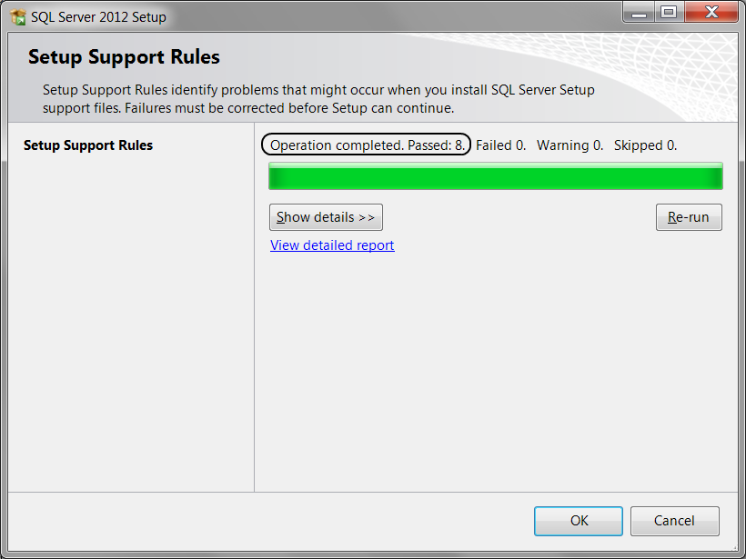
Figure 3. The Setup has passed this computer’s configuration.
- At this point the installation program may check for product updates. This will not always happen but if it does, you will see a screen like the one in figure 4. You can click the Skip Scan button or wait for it to complete.
Important: The SQL Server installation program is dynamic and does not show the same dialog windows for every installation or on every computer! For example, there is a Product Updates page, but if no product updates are discovered, SQL Server Setup may not display this page and will auto advance to the Install Setup Files page. This means that the figures and steps shown in this guide may be different than what you experience on your computer.
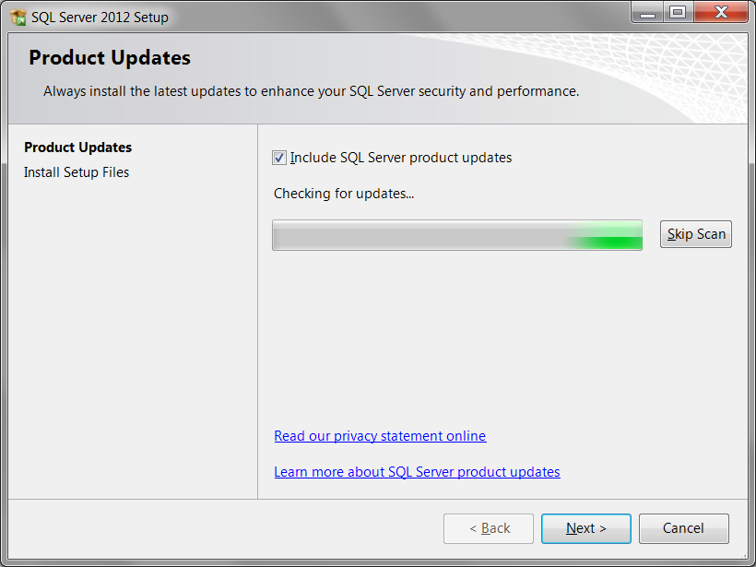
Figure 4. The Product Update dialog during its scan.
- After the scan has completed, you can click the Next button to continue the installation.
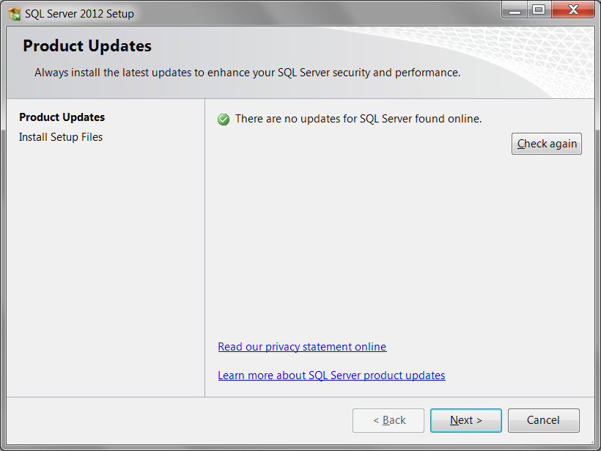
Figure 5. The Product Update dialog after its scan.
- Now, you will see a screen that installs Setup files. Wait for these files to be installed and then the dialog window will automatically continue to a second Setup Support Rules dialog. If for some reason it does not, try clicking the Install button on the bottom of the dialog window.
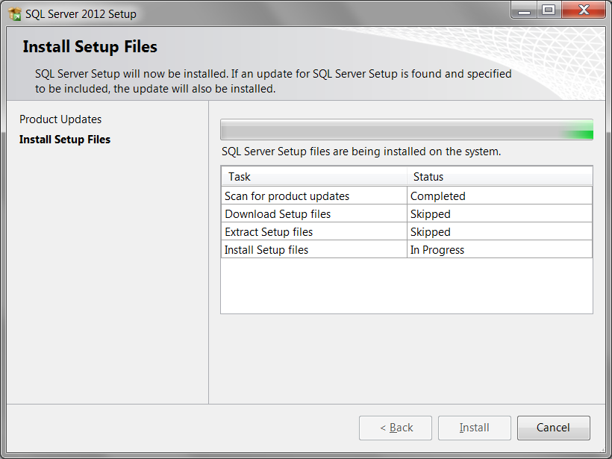
Figure 6. The Install Setup Files dialog.
- When you get to the Setup Support Rules page, the System Configuration Checker runs a discovery operation on your computer. To continue, click Next.
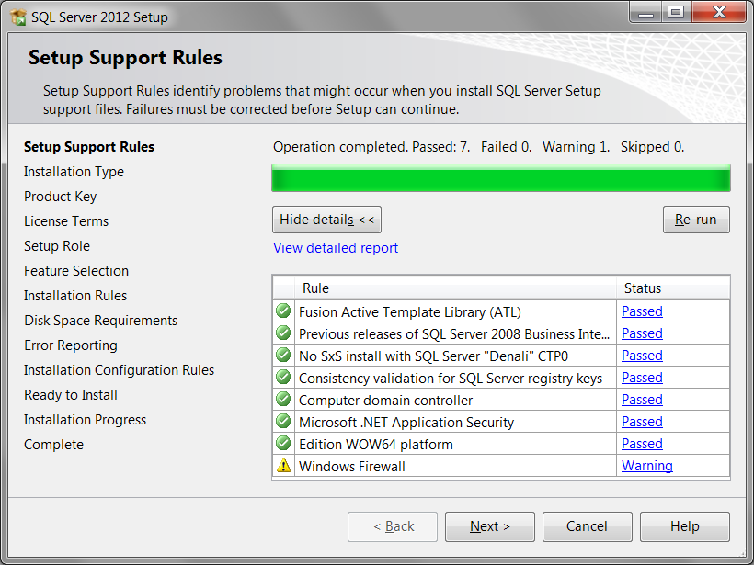
Figure 6. The second Setup Support Rules dialog has passed this computer's configuration.
Dealing with Warnings
You may see warnings in the Setup Support Rules dialog window. If so, you can safely choose to ignore them. For example, the warning in Figure 6 indicates a configuration issue involving Windows Firewall software. Clicking on the provided link presents the dialog shown in Figure 7.
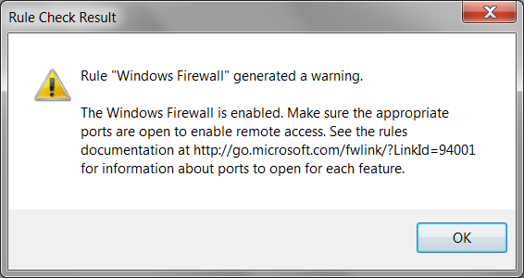
Figure 7. A Rule Check Results dialog.
In addition, Microsoft has provided a detailed report option that gives you more useful information about each topic. This report can be generated by clicking the "View detailed report" link shown in Figure 6.
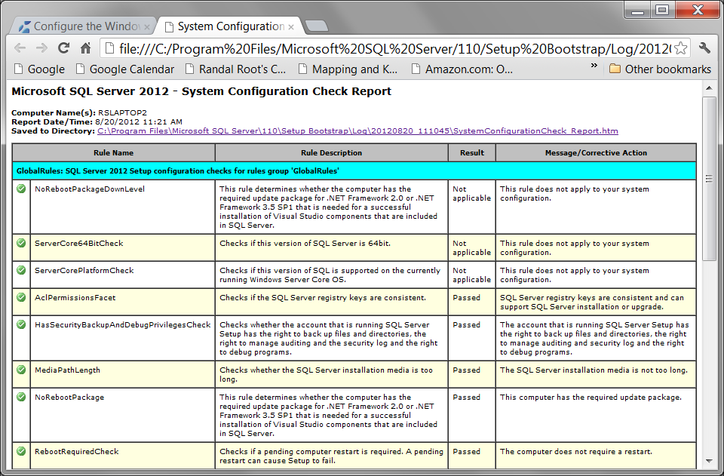
Figure 8. A System Configuration Check Report.
In my example, accessing the recommend links in either the report or the Rule Check Results dialog brings you to one of Microsoft's web pages describing how to configure Windows Firewall to allow access to an instance of the SQL Server through a firewall. This is important if you want to practice connecting to your new SQL installation from other computers, but for the Pro SQL Server 2012 BI Solutions book, it is not necessary.

- When you get to the Installation Type page (Figure 9), indicate that you are installing a new installation of SQL 2012. Click Next to continue.
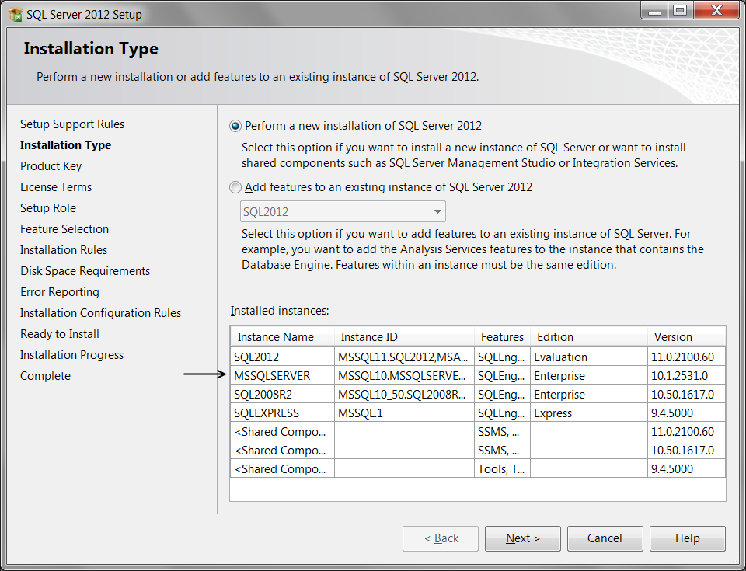
Figure 9. The Installation Type dialog.
Note: SQL Server can be installed a number of times on the same computer, so you may see a list of previously installed instances of SQL Server listed at the bottom of this dialog window. Each installation of SQL Server must be given a unique name, with the exception of the "Default Instance" which automatically is given the name of MSSQLSERVER (Figure 9). Later in the setup, you will be asked to assign a name to the installation (Figure 15).

- When you get to the Product Key page, indicate whether you are installing a free edition or enter a product key (Figure 10). Click Next to continue.

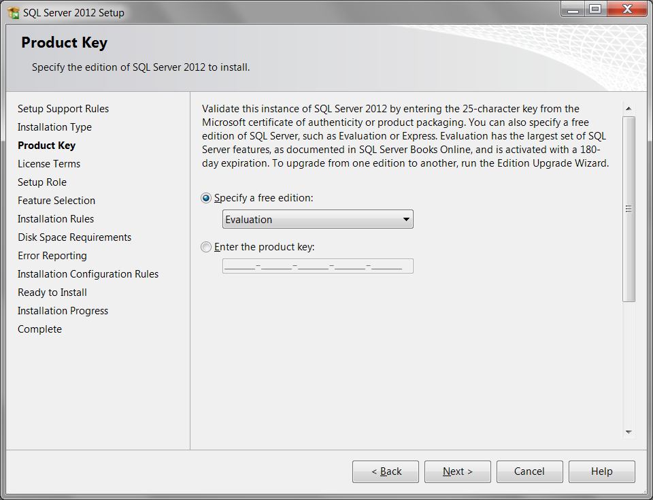
Figure 10. Electing to install the free evaluation edition.
- On the License Terms page, review the license agreement and, if you agree, select the “I accept the license terms” check box, and then click Next to continue (Figure 11).
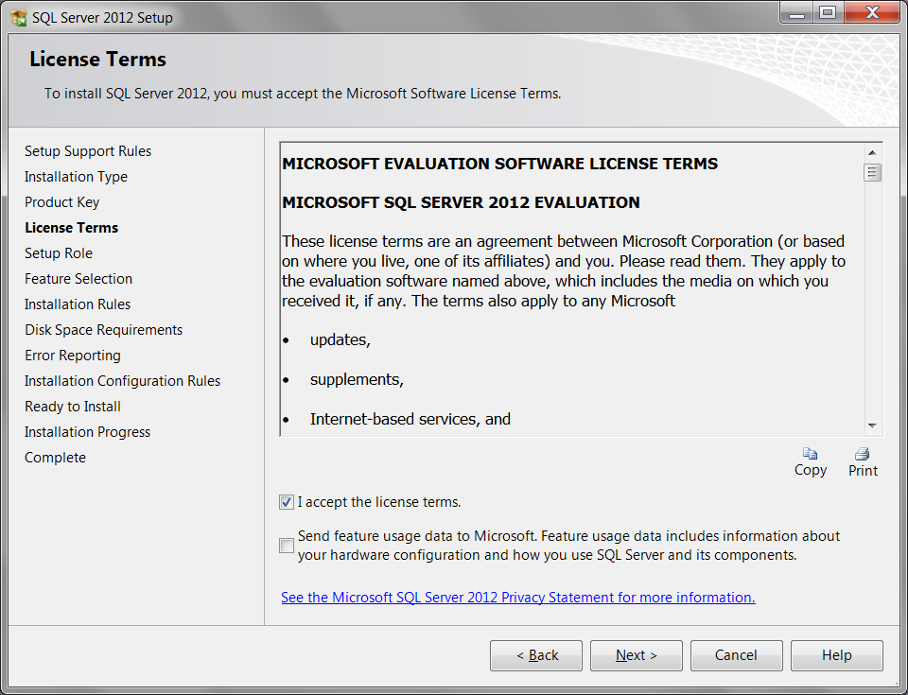
Figure 11. Review the Licensing terms.
- When you reach the Setup Role page, verify that the "SQL Server Feature Installation" radio button is checked, then click the Next button to continue (Figure 12).
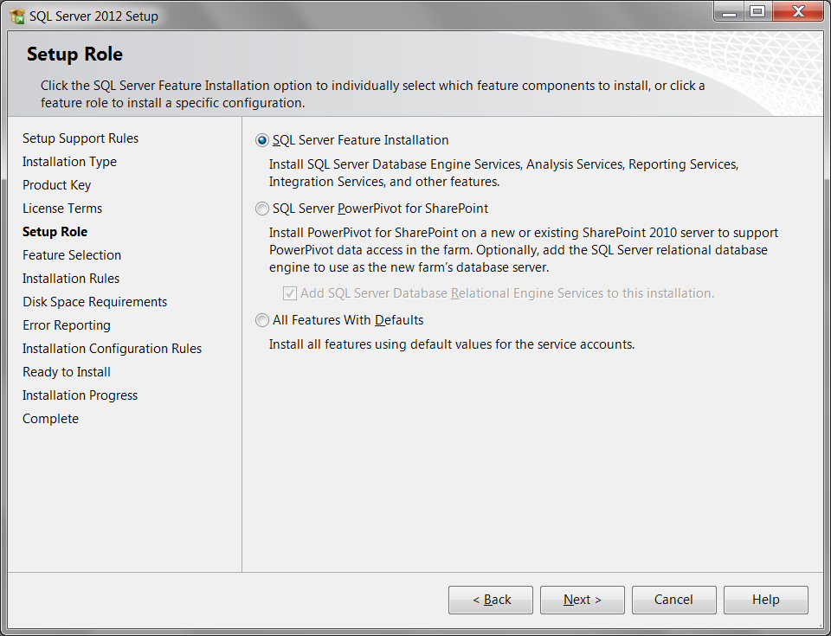
Figure 12. The Setup Role dialog.

- When you reach the Feature Selection page, select the components indicated in Figure 13. These components represent the minimum you will need for use with the Pro SQL Server 2012 BI Solutions book. If a feature is checked, but grayed out, it means that the feature has already been installed by a previous installation of SQL Server. Click the Next button to continue.

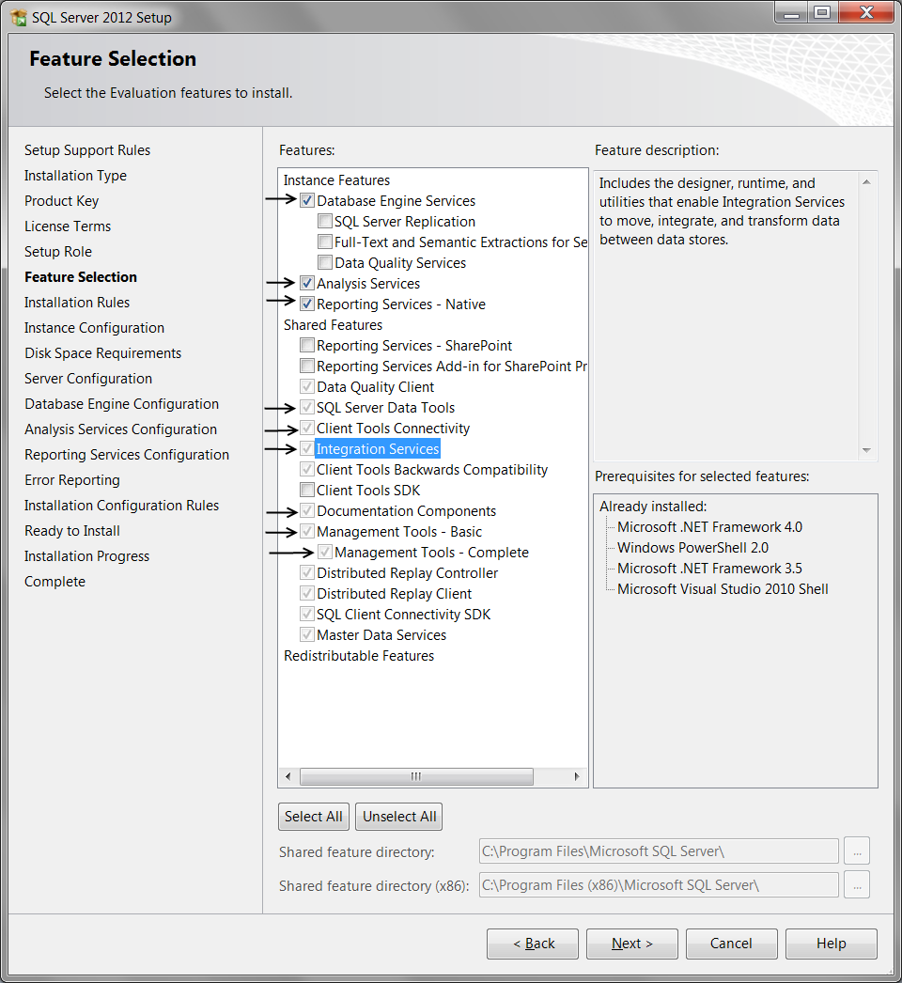
Figure 13. The Feature Selection dialog.
- On the Installation Rules page, Setup verifies the system state of your computer before Setup continues. Once complete, click Next to continue.

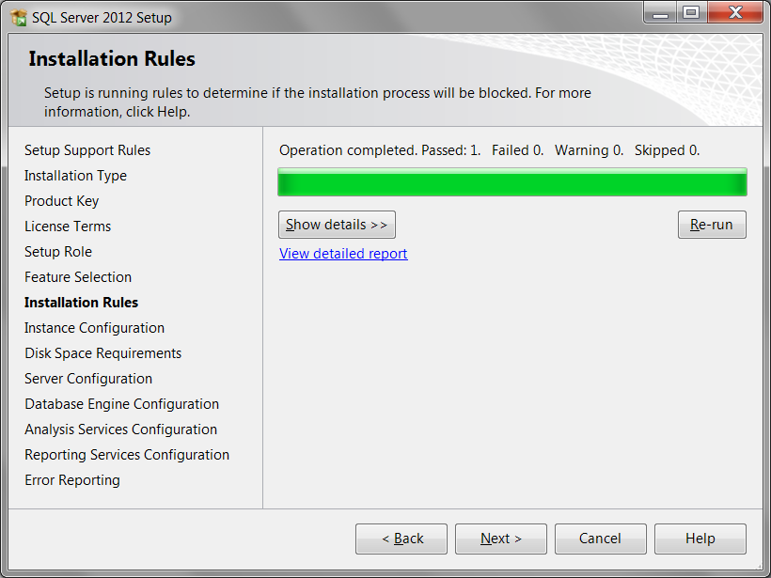
Figure 14. The Installation Rules dialog.
- When you reach the Instance Configuration page, specify whether to install a default instance or a named instance (Figure 15). The Installed instances grid shows instances of SQL Server that are on your computer. If a default instance is already installed on the computer, you must install a named instance of SQL Server 2012 and each name must be unique, but you can make up any name you like. Click Next to continue.

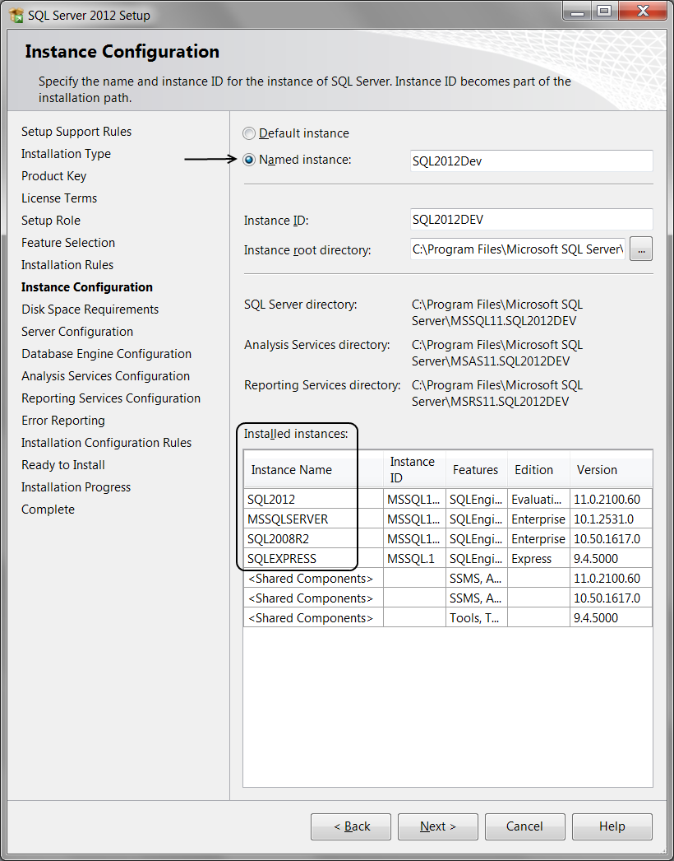
Figure 15. The Instance Configuration dialog.

Note: The Instance ID is used to identify installation directories and registry keys for your instance of SQL Server. By default, the instance name is used as the Instance ID and can be safely left as it is.
- On the Disk Space Requirements page the setup program calculates and displays the required disk space for the features that you specified. If enough space is found, click Next to continue.
- On the Server Configuration — Service Accounts page you configure the login accounts used for the various SQL Server services. Leave the default settings or configure the Account Name to use your own personal administrator account and click next to continue (Figure 16).
High Security or High Flexibility
In a perfect world you would not have to make this decision, but because some people cannot be trusted you need to decide if you are going to use an account with low permission to provide you with high security or a high permission account to provide you with greater flexibility.
On Windows 7, the NT Service account is the default login used by the installation wizard and represents a Windows 7 Virtual Account. It will provide the minimum permission to runs the new services and requires no password. Microsoft recommends that you configure service accounts with the least privileges for each service to grant the minimum permissions they need to complete their tasks. However, this will not always be enough for testing purposes. Consider using your own administrative account on your personal computer if you find you need additional permissions by clicking the Browse option shown in Figure 16, and entering your account name.

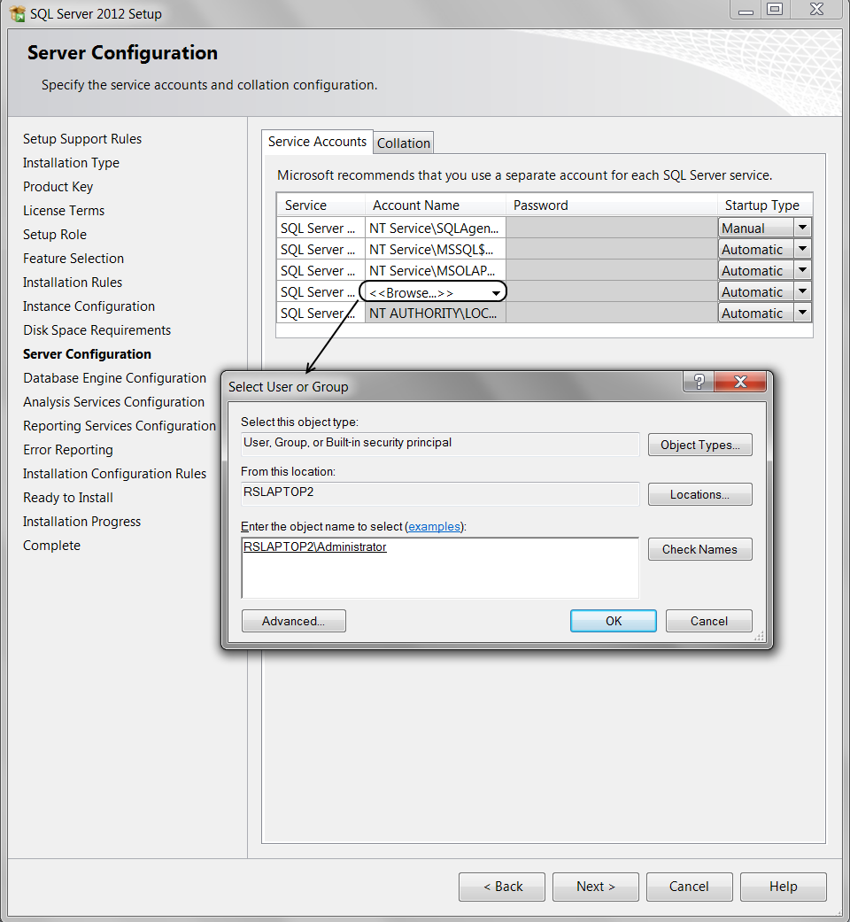
Figure 16. The Instance Configuration dialog.
You can assign the same login account to all SQL Server services, or you can configure each service account individually, with the exception of the SQL Server Browser Service, which must use the LocalService account. You can also specify whether services start automatically, are started manually, or are disabled; automatic startup is recommended.
In the end you must decide which configurations you want to use, but this author has used his personal administrator account on hundreds of classroom computers without a mishap (YET!). Make sure that the computer is protected by a firewall in any case, and never use a high security account in a production environment!

- On the Database Engine Configuration — Server Configuration page, click the Add Current User button, but leave all of the other settings at their default values. Click Next to continue (Figure 19).
Important: The Database Engine Configuration — Server Configuration page is VERY important. Make sure that you click the Add Current User button to add the account you are currently using to the collection of SQL Server administrators. If you do not, you will not be able to access the SQL Server installation! Reinstalling at that point will be the easiest way to fix the problem.
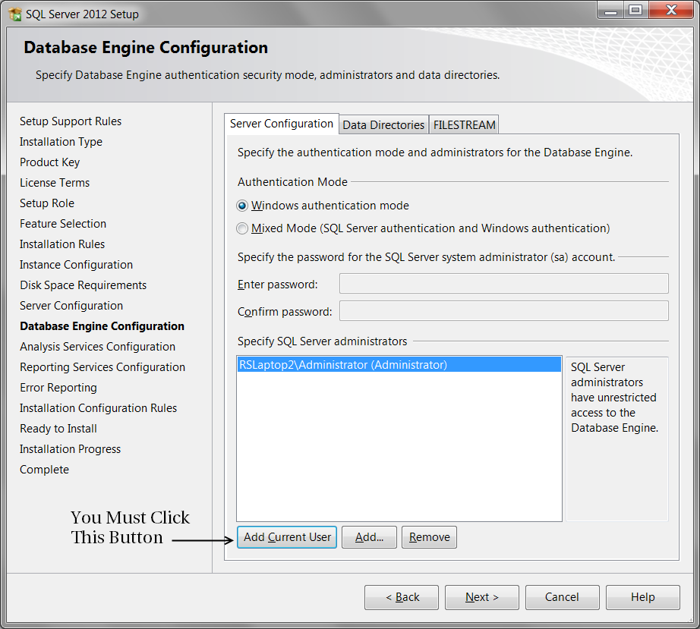
Figure 17. The Database Engine Configuration dialog.

- On the Analysis Services Configuration page specify the server mode and the users or accounts that will have administrator permissions for Analysis Services. For the Pro SQL Server 2012 BI Solutions book, you need to choose the default option, the Multidimensional and Data Mining Mode. You must also specify at least one system administrator for Analysis Services by clicking the Add Current User. After that, click Next to continue (Figure 18).

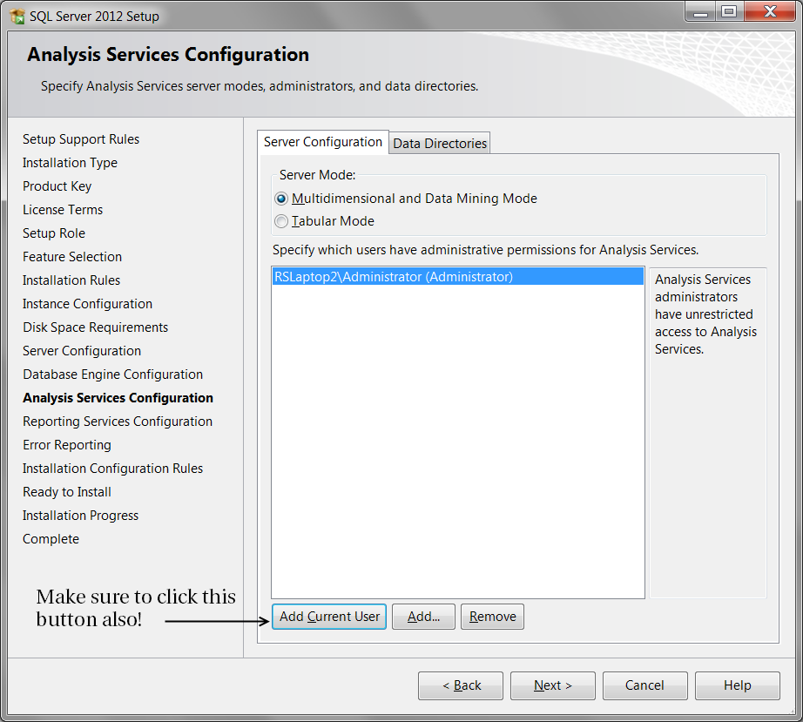
Figure 18. The Analysis Services Configuration dialog.
Important: The Analysis Service Configuration — Server Configuration page is also VERY important. Make sure that you click the Add Current User button to add the account you are currently using to the collection of SQL Server administrators. If you do not, you will not be able to access the Analysis Server installation! Reinstalling at that point will be the easiest way to fix the problem.

- On the Reporting Services Configuration page use the default configuration modes and the options and click Next to continue (Figure 19).
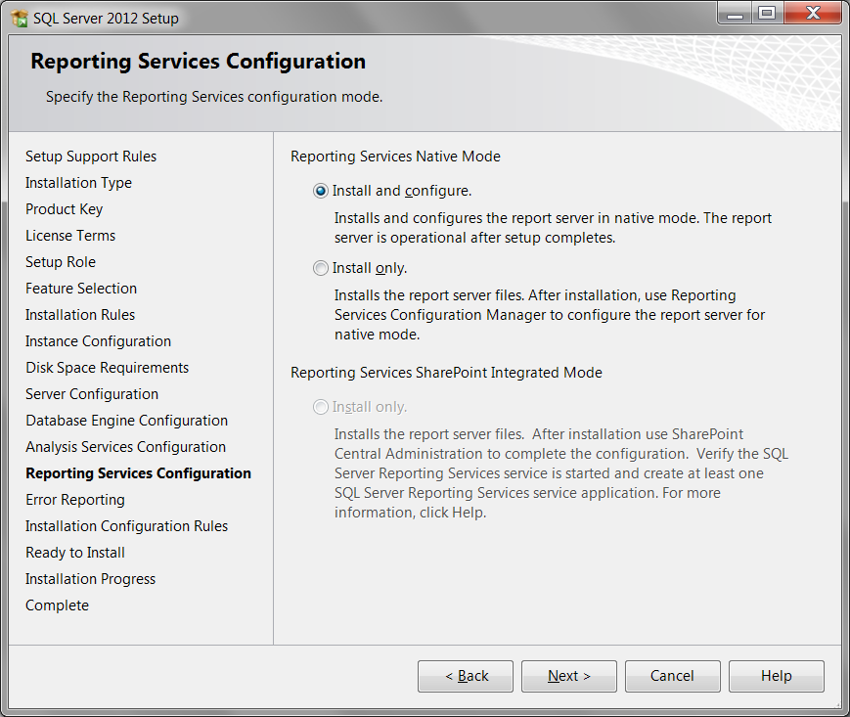
Figure 19. The Reporting Services Configuration dialog.
- On the Error Reporting page, you specify the information that you want to send to Microsoft that will help improve SQL Server. By default, the option for error reporting is enabled and is safe to use. Click Next to continue.
- Let the System Configuration Checker run one more set of rules to validate your computer configuration with the SQL Server features that you have specified and then click Next to display the Ready to Install page.
- The Ready to Install page shows a tree view of installation options that were specified during Setup. Review the configurations once more if you wish and then click Install (Figure 20).
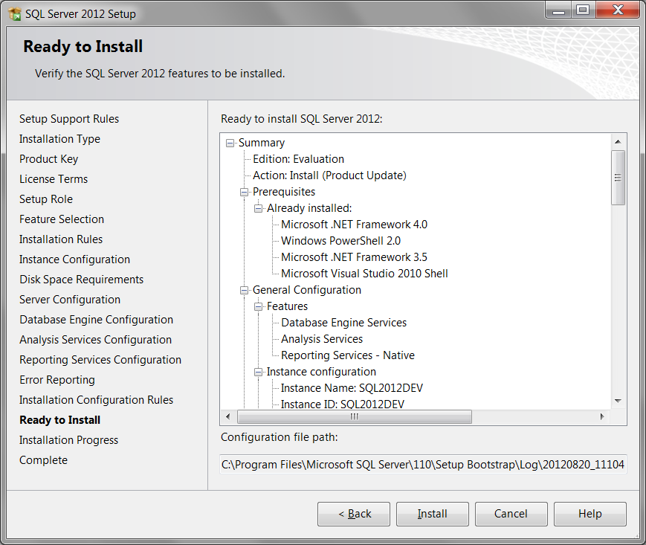
Figure 20. The Reporting Services Configuration dialog.
- Now Wait! Installing these components can take a while, and it is important that you wait for it to finish and not click the cancel button by mistake.
- Once everything is installed, you complete the SQL Server installation process by clicking Close.
- We recommend that you restart the computer after you have finished with Setup.
Congratulations, you now have a working installation of SQL Server, Analysis Server, Integration Server, and Reporting Server!

